User need to have python >=3.5+ install in their system.

User can install all dependencies for the application using requirements.txt file present in the folder.
One can use following command for same :
python3 -m pip install --user -r /path_where_project/searchProject/requirements.txt

User also need to have R installed in their system beforehand.
R related packages required : GenomicRanges
Rpy2 library used in this project creates a bridge between R and python.

In order to install tkinter which provides GUI for the app, user needs to install it using following command :
apt-get install python3-tk

Finally user can run the application by reaching into the searchProject folder and running following command :
"python3 scepisearch.py"
If all dependencies work well, user can see the GUI.

Note : If user runs into the error "OSError: cannot load library '/home/cell/R/lib/R/lib/libR.so': libBblas.so: shared Cannot open object file: there is no such file or directory "
Solution : User needs to add path : export LD_LIBRARY_PATH = "/path-to-R-installation/lib/R/lib:$LD_LIBRARY_PATH"
-------------------------------------------------------------------------------------------------------------------
If user is executing from location machine, GUI will work fine.
Otherwise if user is executing from remote server, Following process has to be followed :
1. If local system is windows, User needs to install Xming from : https://sourceforge.net/projects/xming/
Afterwards, user should login to remote server from putty and tick X11 forwarding :

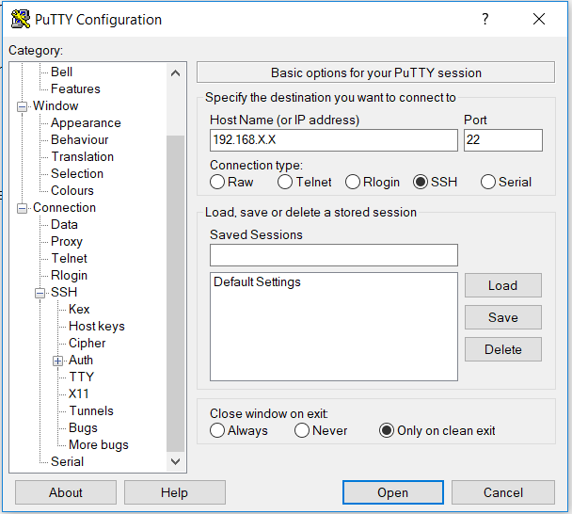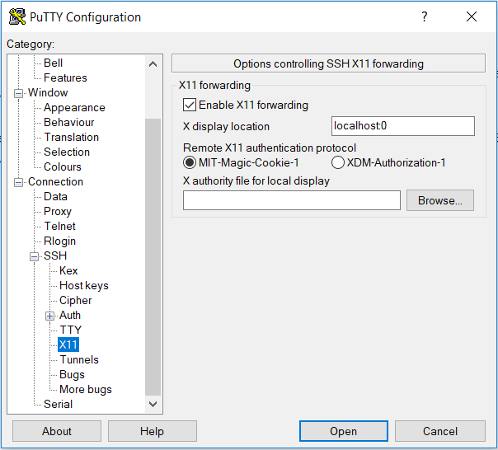

2. If user is accessing remote server from linux based local system, then user can login to remote server with -X ssh login.
For eg, ssh -X username@192.168.X.X

